[ARTICLE TITLE]
First AUTHOR¹, Second AUTHOR², Third AUTHOR¹, Fourth AUTHOR^{3,*}
¹ Department, Institution, City, Country
² Department, Institution, City, Country
³ Department, Institution, City, Country
e-mail: author1@domain.tld, author2@domain.tld, author3@domain.tld, author4@domain.tld
Received: [Month YEAR]
Abstract. Replace this text with your abstract (normally no more than 150 words). The abstract should be self-contained and should not include references, table/figure numbers, or undefined abbreviations.
Key words: keyword1, keyword2, keyword3, keyword4.

Introduction
This document is a demonstration file for Informatics in Education (INFEDU). It shows the expected layout, running headers, and common elements such as numbered headings, tables, figures, references, and appendices.
Body text uses 11 pt Times New Roman, justified, with a first-line indent of 0.5 cm. Avoid manual formatting; instead, apply the provided styles.
For print production, keep all figures and tables inside the text area (within margins). If you need a large figure, scale it to the text width and let the editor decide final placement.

Subsection heading
Lorem ipsum dolor sit amet, consectetur adipiscing elit. Integer nec odio. Praesent libero. Sed cursus ante dapibus diam. Sed nisi. Nulla quis sem at nibh elementum imperdiet. Duis sagittis ipsum.
Lorem ipsum dolor sit amet, consectetur adipiscing elit. Integer nec odio. Praesent libero. Sed cursus ante dapibus diam. Sed nisi. Nulla quis sem at nibh elementum imperdiet. Duis sagittis ipsum.
Lorem ipsum dolor sit amet, consectetur adipiscing elit. Integer nec odio. Praesent libero. Sed cursus ante dapibus diam. Sed nisi. Nulla quis sem at nibh elementum imperdiet. Duis sagittis ipsum.
Lorem ipsum dolor sit amet, consectetur adipiscing elit. Integer nec odio. Praesent libero. Sed cursus ante dapibus diam. Sed nisi. Nulla quis sem at nibh elementum imperdiet. Duis sagittis ipsum.
Lorem ipsum dolor sit amet, consectetur adipiscing elit. Integer nec odio. Praesent libero. Sed cursus ante dapibus diam. Sed nisi. Nulla quis sem at nibh elementum imperdiet. Duis sagittis ipsum.
Lorem ipsum dolor sit amet, consectetur adipiscing elit. Integer nec odio. Praesent libero. Sed cursus ante dapibus diam. Sed nisi. Nulla quis sem at nibh elementum imperdiet. Duis sagittis ipsum.

Subsubsection heading
Praesent mauris. Fusce nec tellus sed augue semper porta. Mauris massa. Vestibulum lacinia arcu eget nulla. Class aptent taciti sociosqu ad litora torquent.
Praesent mauris. Fusce nec tellus sed augue semper porta. Mauris massa. Vestibulum lacinia arcu eget nulla. Class aptent taciti sociosqu ad litora torquent.
Praesent mauris. Fusce nec tellus sed augue semper porta. Mauris massa. Vestibulum lacinia arcu eget nulla. Class aptent taciti sociosqu ad litora torquent.
Praesent mauris. Fusce nec tellus sed augue semper porta. Mauris massa. Vestibulum lacinia arcu eget nulla. Class aptent taciti sociosqu ad litora torquent.
Praesent mauris. Fusce nec tellus sed augue semper porta. Mauris massa. Vestibulum lacinia arcu eget nulla. Class aptent taciti sociosqu ad litora torquent.
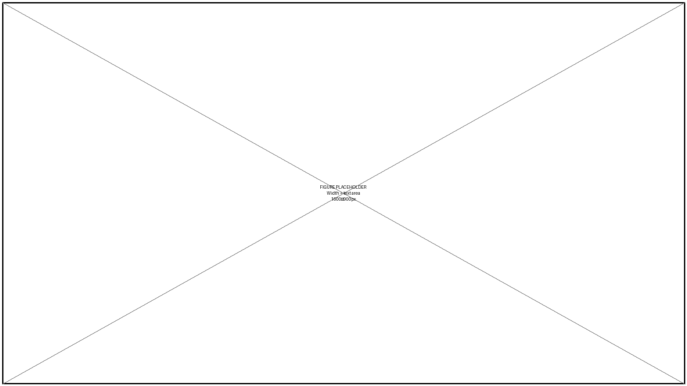
Fig. 1. Example of a figure fitted to the text width (print-safe).
Refer to Fig. 1 in the text. Figures should be placed close to the first mention. Use the 'INFEDU Figure Caption' style for captions.
Table 1. Example table (caption above the table).
Column 1 | Column 2 | Column 3 | Column 4
1,1 | 1,2 | 1,3 | 1,4
2,1 | 2,2 | 2,3 | 2,4
3,1 | 3,2 | 3,3 | 3,4
4,1 | 4,2 | 4,3 | 4,4
5,1 | 5,2 | 5,3 | 5,4
Table text uses 10 pt. Use repeating header rows for multi-page tables.

Results and long tables
The next table is intentionally long (spans more than one page) to demonstrate: (a) repeating header row, (b) stable column widths, and (c) caption style.
Table 2. Long table example (continues on the next page).
ID | Variable | Definition (short) | Example value | Notes
1 | Var_01 | Short description that may wrap to the next line for realistic layout. | 0.628 | Use 10 pt text; avoid tiny fonts.
2 | Var_02 | Short description that may wrap to the next line for realistic layout. | 0.663 | Use 10 pt text; avoid tiny fonts.
3 | Var_03 | Short description that may wrap to the next line for realistic layout. | 0.547 | Use 10 pt text; avoid tiny fonts.
4 | Var_04 | Short description that may wrap to the next line for realistic layout. | 0.327 | Use 10 pt text; avoid tiny fonts.
5 | Var_05 | Short description that may wrap to the next line for realistic layout. | 0.835 | Use 10 pt text; avoid tiny fonts.
6 | Var_06 | Short description that may wrap to the next line for realistic layout. | 0.072 | Use 10 pt text; avoid tiny fonts.
7 | Var_07 | Short description that may wrap to the next line for realistic layout. | 0.922 | Use 10 pt text; avoid tiny fonts.
8 | Var_08 | Short description that may wrap to the next line for realistic layout. | 0.354 | Use 10 pt text; avoid tiny fonts.
9 | Var_09 | Short description that may wrap to the next line for realistic layout. | 0.488 | Use 10 pt text; avoid tiny fonts.
10 | Var_10 | Short description that may wrap to the next line for realistic layout. | 0.477 | Use 10 pt text; avoid tiny fonts.
11 | Var_11 | Short description that may wrap to the next line for realistic layout. | 0.875 | Use 10 pt text; avoid tiny fonts.

Large figures (print-safe)
Large figures are allowed, but must still fit within the margins. If a figure needs to be very large, prefer text-width figures, or split into panels.

Fig. 2. Example of a large square figure scaled to the text width.
Appendix A. Supplementary material
Appendices are optional. Use them for material that supports the paper but would interrupt the main flow (e.g., survey instruments, full rubrics, additional analyses).
A.1. Example appendix subsection
This is appendix body text (Normal style).
References
Author, A. A., & Author, B. B. (2024). Article title. Journal Title, 12(3), 123-145.
Author, C. C. (2022). Book title. Publisher, City.
Organization. (2020). Web resource title. Retrieved from https://example.org
Style quick reference (delete before submission)
This table lists the key styles defined in the template and the intended formatting. Use styles (not manual formatting) to keep manuscripts consistent.
Table 3. INFEDU styles and intended use.
Style name | Use | Font | Size | Bold/Italic | Alignment | Notes
INFEDU Header | Page header text | Times New Roman | 10 | Roman / Italic | Left/Right | Odd/even headers; first page differs
INFEDU Footer | Footer area | Times New Roman | 10 | Roman | Left | Used in the footer of the first page for a note about the corresponding author. In the INFEDU layout, there is no footer on other pages.
INFEDU Preamble | Journal line/DOI | Times New Roman | 11 | Roman | Left | Used on first page header (editorial placeholders)
INFEDU Title | Article title | Times New Roman | 14 | Roman | Left | Avoid manual line breaks
INFEDU Authors | Author names | Times New Roman | 12 | Roman | Left | Use superscripts for affiliations
INFEDU Affiliations | Affiliation block | Times New Roman | 10 | Italic | Left | One per line
INFEDU Email | e-mail line | Times New Roman | 10 | Italic | Left | List all author emails
INFEDU Abstract | Abstract paragraph | Times New Roman | 11 | Roman (label bold) | Justified | No first-line indent
INFEDU Keywords | Key words line | Times New Roman | 11 | Roman (label bold) | Left | Comma-separated
Heading 1 | Numbered section heading | Times New Roman | 11 | Bold | Left | Auto-numbered 1., 2., …
Heading 2 | Numbered subsection heading | Times New Roman | 11 | Italic | Left | Auto-numbered 1.1., 1.2., …
Heading 3 | Numbered subsubsection heading | Times New Roman | 11 | Italic | Left | Auto-numbered 1.1.1., …
Normal | Body text | Times New Roman | 11 | Roman | Justified | First-line indent 0.5 cm
INFEDU Table Text | Table text | Times New Roman | 10 | Roman | Left | No first-line indent
INFEDU Table Caption | Table caption (above) | Times New Roman | 10 | Roman | Centered | Use 'Table X.' prefix
INFEDU Figure Caption | Figure caption (below) | Times New Roman | 10 | Roman | Centered | Use 'Fig. X.' prefix
INFEDU Reference | Reference entries | Times New Roman | 10 | Roman | Justified | Hanging indent 0.5 cm
INFEDU Appendix Heading | Appendix heading | Times New Roman | 11 | Bold | Left | Appendix A, Appendix B, …
INFEDU Appendix Subheading | Appendix subsection | Times New Roman | 11 | Italic | Left | A.1, A.2, …

